Caed lab # 8

Rabia

Fa17-bece-2001

Task1

num = input(" give any no?");

if(num > 50)

disp (" greater than 50");

elseif( num< 50)

disp (" no is less than 50");

else

disp(" no is equal to 50");

end

Output

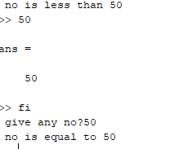

Task2

x = input(" give any no?");

if(x < 5)

y=2\*(x)+1;

disp(y);

else

y=2\*x;

disp(y);

end

Output



Task3

a=input("1st no");

b=input("2nd no");

c=input("3rd no");

if (a>b)&&(a>c)

disp(a);

elseif (b>a)&&(b>c)

disp(b);

else

disp(c);

end

Output

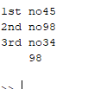

Task4

n=input(" max no");

for a=1:n

a=a^2;

disp(a);

end

Output

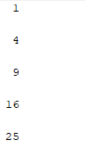

Task5

a=10;

b=1;

fact=1;

while(b<=a)

fact=fact\*b;

b=b+1;

end

disp(fact);

output

